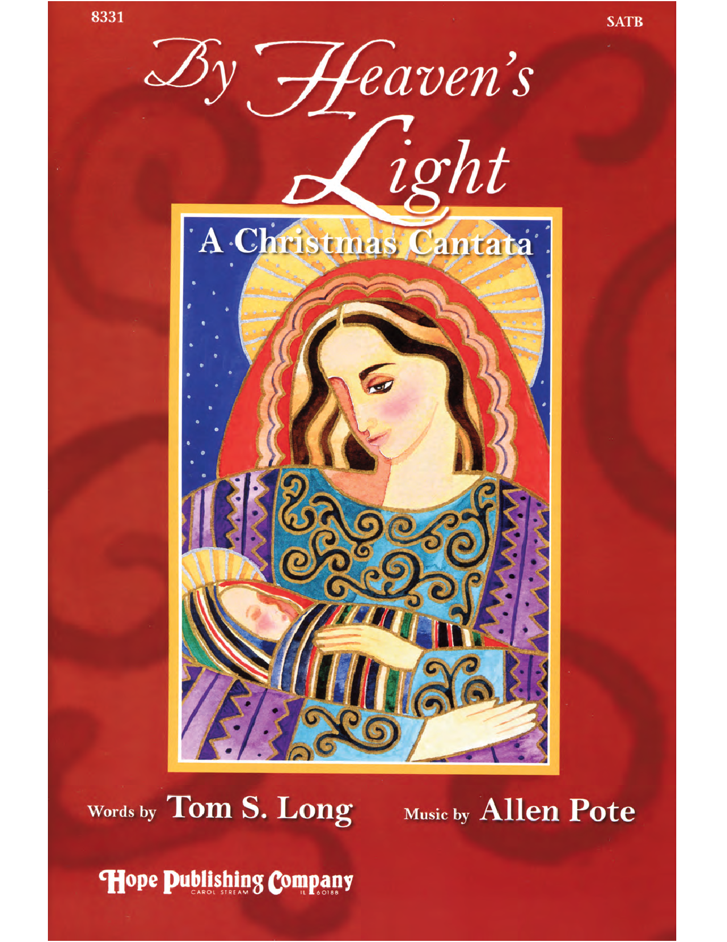

WELCOME

CELEBRATION OF FRIENDSHIP

CHRISTMAS MESSAGE
“The Christmas Church”

THE LORD’S PRAYER

CELEBRATION OF HOLY COMMUNION

JOY OF GIVING

By Heaven’s Light

Prepare the Way of the Lord
Emmanuel
The Angel Gabriel
Mary’s Song
The Journey
Song of the Angels
March of the Kings
Away in a Manger
One Flame

Christ Church Choir and Orchestra
Conducted and Directed by Michael Curran

